|  |  |  |
| --- | --- | --- |
|  | Faculty of Computing, Engineering and Science |  |

**Assessment Cover Sheet and Feedback Form** 2022-23

|  |  |  |  |
| --- | --- | --- | --- |
| Module Code:  IS4S761 | Module Title:  Principles of Computing | | Module Team:  Gaylor Boobyer |
| Assessment Title and Tasks:  Portfolio 1 - Element 1 | | | Assessment No.  1 |
| Date Set:  **07-Oct-22** | | Submission Date:  **11-Nov-22** | Return Date:  **09-Dec-22** |

|  |  |
| --- | --- |
| ***Part A: Record of Submission (to be completed by Student)*** | |
| **Extenuating Circumstances**  If there are any exceptional circumstances that may have affected your ability to undertake or submit this assignment, make sure you contact the Advice Centre on your campus prior to your submission deadline. | |
| **Fit to sit policy**:  The University operates a fit to sit policy whereby you, in submitting or presenting yourself for an assessment, are declaring that you are fit to sit the assessment. You cannot subsequently claim that your performance in this assessment was affected by extenuating factors. | |
| **Plagiarism and Unfair Practice Declaration:**  By submitting this assessment, you declare that it is your own work and that the sources of information and material you have used (including the internet) have been fully identified and properly acknowledged as required[1]. Additionally, the work presented has not been submitted for any other assessment. You also understand that the Faculty reserves the right to investigate allegations of plagiarism or unfair practice which, if proven, could result in a fail in this assessment and may affect your progress. | |
| **Details of Submission:**  Note that all work handed in after the submission date and within 5 working days will be capped at 40%[2]. No marks will be awarded if the assessment is submitted after the late submission date unless extenuating circumstances are applied for and accepted (Advice Centre to be consulted). | |
| **You are required to acknowledge that you have read the above statements by writing your student number (s) in the box:** | Student Number: 30076078 |

**IT IS YOUR RESPONSIBILITY TO KEEP RECORDS OF ALL WORK SUBMITTED**

|  |
| --- |
| **Marking and Assessment** |
| This assignment will be marked out of 100%  This assignment contributes to 25% of the total module marks.  **Assessment Task:**  Using the scenario given in Appendix A, analyse the requirements and then:  a) Expand upon the already given partial ERD (Appendix B) and thus produce an ERD that models a new system for Glam Cars that will satisfy all the requirements detailed in the scenario given. The partial ERD may change slightly when you produce your complete ERD, depending on the assumptions you make.  b) State any assumptions made during the development of your design.  (The ‘What’ and ‘Why’) |

|  |
| --- |
| **Learning Outcomes to be assessed** (as specified in the validated module descriptor [https://icis.southwales.ac.uk/](https://icis.southwales.ac.uk/studentmodules/13802/studentmodulespecifications) ):  1) To demonstrate a practical understanding of the design of information systems.  2) To design and implement a database system that meets a set of requirements and avoids data redundancy. |
| *Provisional mark only: subject to change and / or confirmation by the Assessment Board* |

**Appendix A**

**Glam Cars**

Glam Cars is an organisation that consists of a number of centres that both sells and hires cars to customers. A car is either available for hire or is for sale. It cannot be both.

**Car Sales**

Each centre will employ a number of sales staff. Sales staff are employed at one centre only.

Each car sale for the previous 6 months is recorded and after 6 months is automatically archived. (You need not consider the archiving of car sales for this coursework). For each sale, made by a salesperson, they will earn a commission based on the following table:

**Car Price(£) % Commission**

0-5000 2

5000-10000 3

10000-15000 4

15000+ 5

For simplicity, assume that the car is always sold for the price specified in the car details table.

You will need to record this commission rate somewhere within your database – either as an attribute in a table, or as a separate table.

Customer details are retained for marketing purposes even if they have not purchased a car recently. Some customers will not purchase a car outright, but will make an agreement to pay a deposit and pay the balance over the next two years. The recording of deposits and payments is outside the remit of this database system, but customers who have broken their agreements will need to be recorded on the system as ‘bad debtors’ until they pay in full.

**Car Hire**

Whilst most hire contracts are for one car only, some hire contracts can be for one or more cars.

A record is kept of past, current and future hire contracts. Past hire contract details are kept for 6 months and then archived. (You need not consider the archiving of hire contracts for this coursework).

Details of all customers, past and present, are kept.

**Glam Cars continued.**

If the outstanding sum is not paid by this date, then the customer is classed as a ‘bad debtor’ and not allowed to hire any more cars until the debt is paid. if the customer refuses to pay this additional charge, he/she will be classed as a ‘bad debtor’ and not allowed to hire any more cars until the debt is paid.

Hire cars will need to be serviced and/or repaired and Glam Cars have a number of garages under contract that any hire car can be sent to for service/repair. A record needs to be retained that details where and when a service/repair takes place.

**Appendix B**

**Partial ERD for Glam Cars**

1

1

0..*

1..*

1

0..*

Centre

Customer

Salesman

Car for Sale

# Marking Scheme:

|  |  |  |  |  |  |  |
| --- | --- | --- | --- | --- | --- | --- |
|  | Fail | Narrow Fail | 3rd Class / Pass | Lower 2nd Class / Pass | Upper 2nd Class / Merit | 1st Class / Distinction |
| ERD 80% | * Missing any understanding of this technique. Model fails to represent case study and/or requiresextensive corrections | * Missing or demonstrating little understanding of this technique. Model fails to represent case study and/or require extensive corrections | * Model loosely represents the case study. Reasonable use of notation but contains some major errors or several small errors. Adequate attempt at rationalising MM relationships (if needed) | * Model represents many aspects of the case study. Many entity types & relationships included. Good use of notation but contains some errors. reasonable attempt at rationalising MM relationships (if needed) | * Model represents the main aspects of the case study. Most entity types & relationships included. Good use of notation and contains only a few errors. Good attempt at rationalising MM relationships (if needed) | * Model clearly represents the case study. All appropriate entity types & relationships included. Excellent use of notation and very few errors. Clear & correct rationalising of MM relationships (if needed) |
| Assumptions 20% | * No Assumptions | * Missing or inappropriate assumptions unrelated to the design of the ERD | * Some basic assumptions made related to the design of the ERD. Mostly WHAT was decided re the design rather than WHY it was decided | * A reasonably good set of assumptions made which are related to the design of the ERD. Mostly WHAT was decided re the design rather than WHY it was decided | * A good set of assumptions appropriate to the design of the ERD. Includes mainly WHAT was decided re the design but a good attempt at the WHY | * An excellent set of appropriate assumptions.Includes both the WHAT was decided re the design and the WHY it was decided |
|  | | | | | | |

Answer:

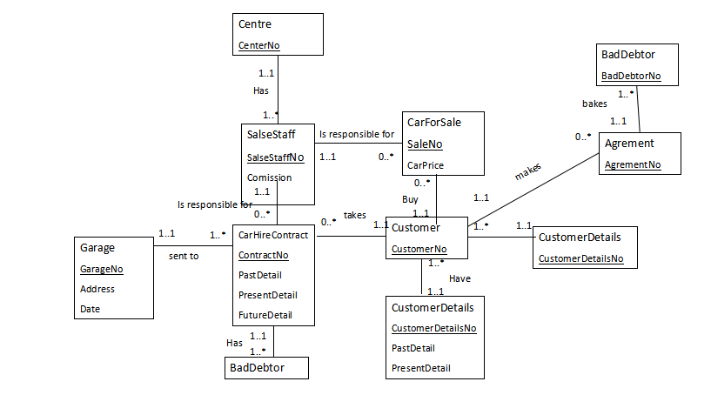

Assumption:

**Car Sales:** A Centre must have at least one SalesStaff but can have many and a SalesStaff must work under one and only one Centre. A SalesStaff is responsible for no CarForSale but many and a CarForSale have the responsibility of a SalesStaff. A Customer may buy no Car but many Car and a CarForSale have the responsibility of only one Customer. Then, CustomerDetails cannot exist without having any related Customer(Mandatory) and A Customer cannot exist without a related CustomerDetails(Mandatory). A Customer may make no Agrement but many and an Agrement is hold by only one Customer. An agrement breaks must at least one BadDebtor but many and A BadDebtor must have one Agrement.

**Car Hire:** A SalesStaff can provide no CarHireContract but many and a CarHireContract have the responsibility of only one SalesStaff. A Customer may take no CarHireContract but many and a CarHireContract have the responsibility of only one Customer. A CustomerDetails cannot exist without having any related Customer(Mandatory) and A Customer cannot exist without a related CustomerDetails(Mandatory) and recoring as an attribute for Customer past and present details. A BadDebtor cannot exist without having any related CarHireContract(Mandatory) and A CarHireContract cannot exist without a related BadDebtor (Mandatory). CarHireContract (Hire Cars) sent to only one Garage for servicing and a Garage holds must at least one or many CarHireContract.

1. University Academic Integrity Regulations
2. Information on exclusions to this rule is availablefrom Campus Advice Shops